**HFS Sales Manager User Manual**

# **Introduction:**

Welcome to the Sales Manager Web App! This platform is designed to help you manage and monitor your sales team, track performance, and access essential sales tools. As a Sales Manager, you can easily oversee the daily activities of your team, analyze performance trends, and ensure all sales processes are being executed efficiently.

This manual will guide you through the various features of the web app and help you make the most out of the tools available.

# Dashboard:

Upon logging into the web app, you will be directed to the Dashboard, the central hub where you can monitor key sales metrics and team performance. Here's what you can do on the dashboard:

## Monitor Team Performance:

The Team Performance section provides a high-level overview of your team's performance. You can track:

* Revenue generated
* Total calls
* Invoices
* Total orders
* Orders value
* Quotations

You can refer to Fig 1 to see the overview of the dashboard.

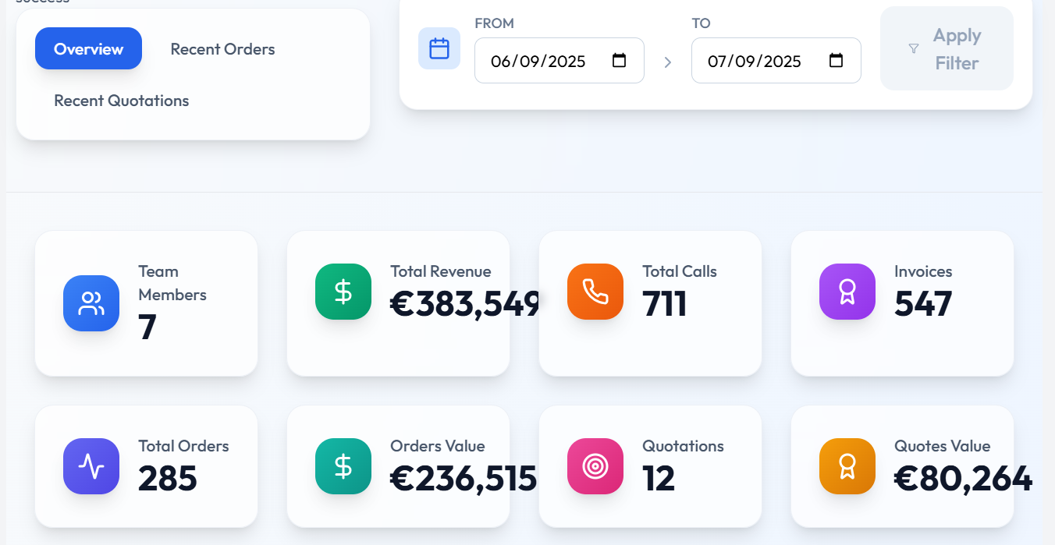

Fig 1. Overview of sales manager dashboard

You can view the recent orders placed by your team by clicking the **recent orders** button as shown in Fig 2.

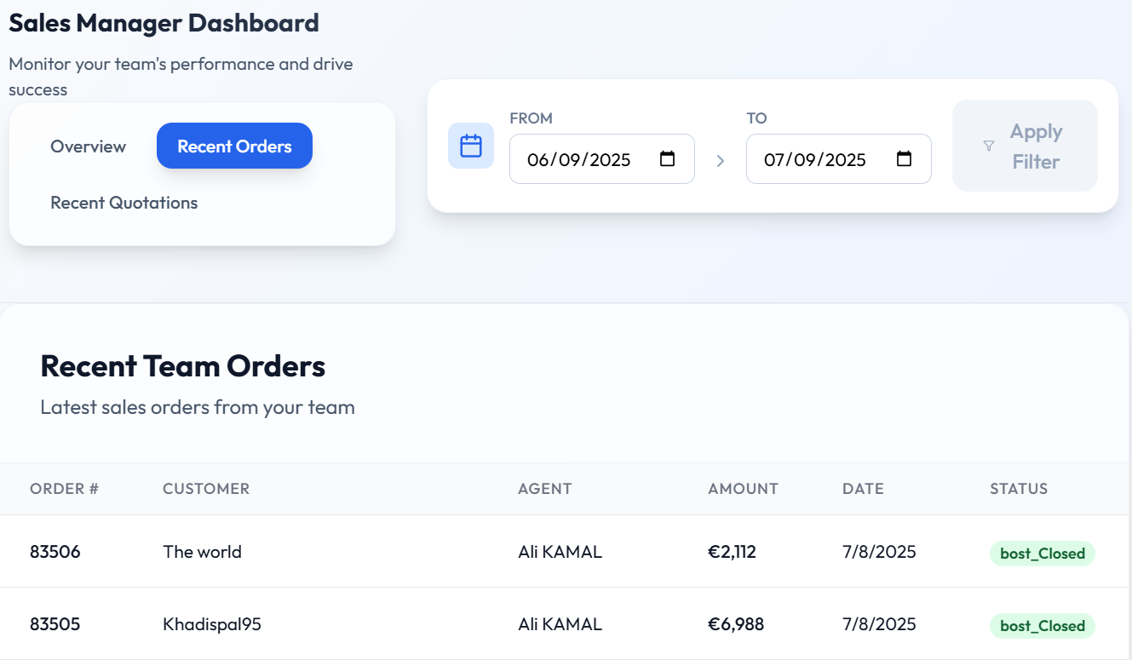

Fig 2. Recent orders placed by the sales agent being viewed on the sales manager dashboard

You can also view the recent quotations by clicking on the recent quotations button on the dashboard.

## Performance Trends

In this section, you can analyze performance trends of your team based on:

* Revenue
* Orders
* Quotations

You can view the performance trends chart in Fig 3.

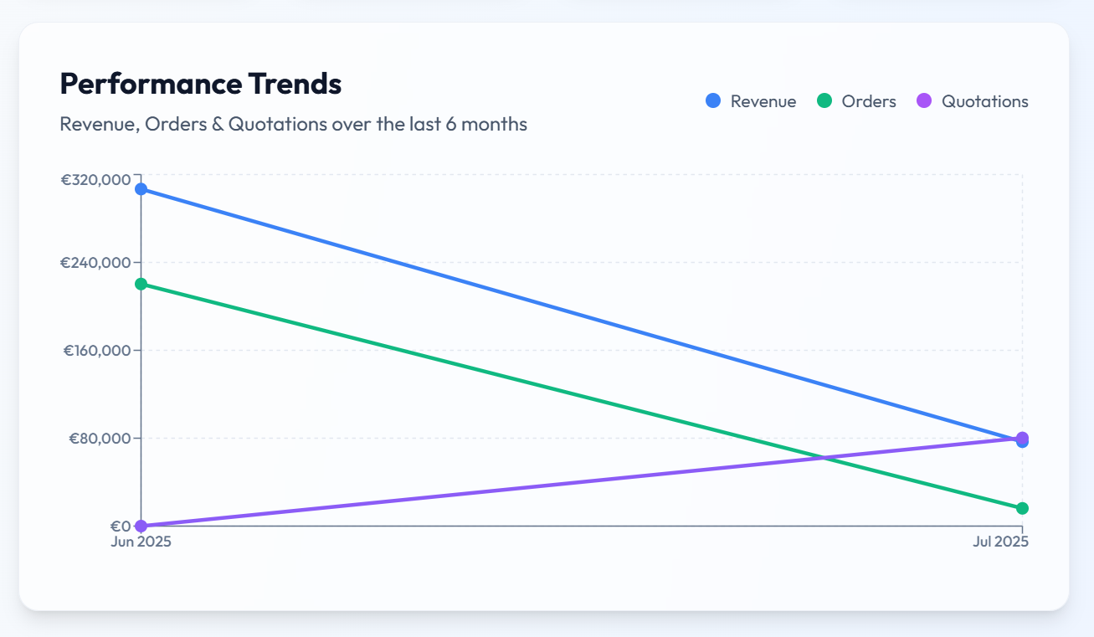  
Fig 3. Performance trends over the last 6 months being displayed

This data allows you to easily spot patterns, such as seasonal trends or periods of high activity, and adjust strategies accordingly.

## View All Agents:

To access detailed performance metrics for individual sales agents:

* Click the **view all agents** button as shown in Fig 4
* You will be redirected to the analytics page

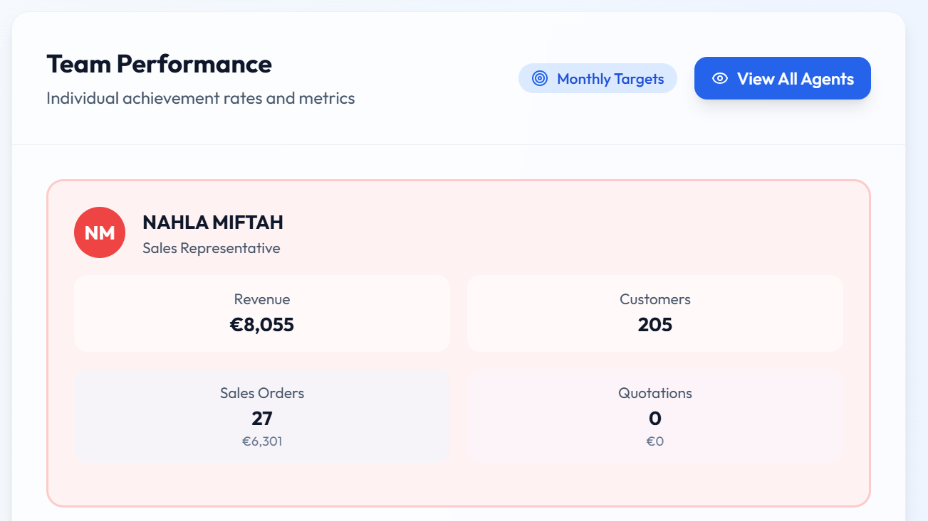

Fig 4. Team performance metrics with the monthly targets and view all agents button on the top

# View and Edit Your Profile:

This section displays your personal and account related information and can be seen in Fig 5.

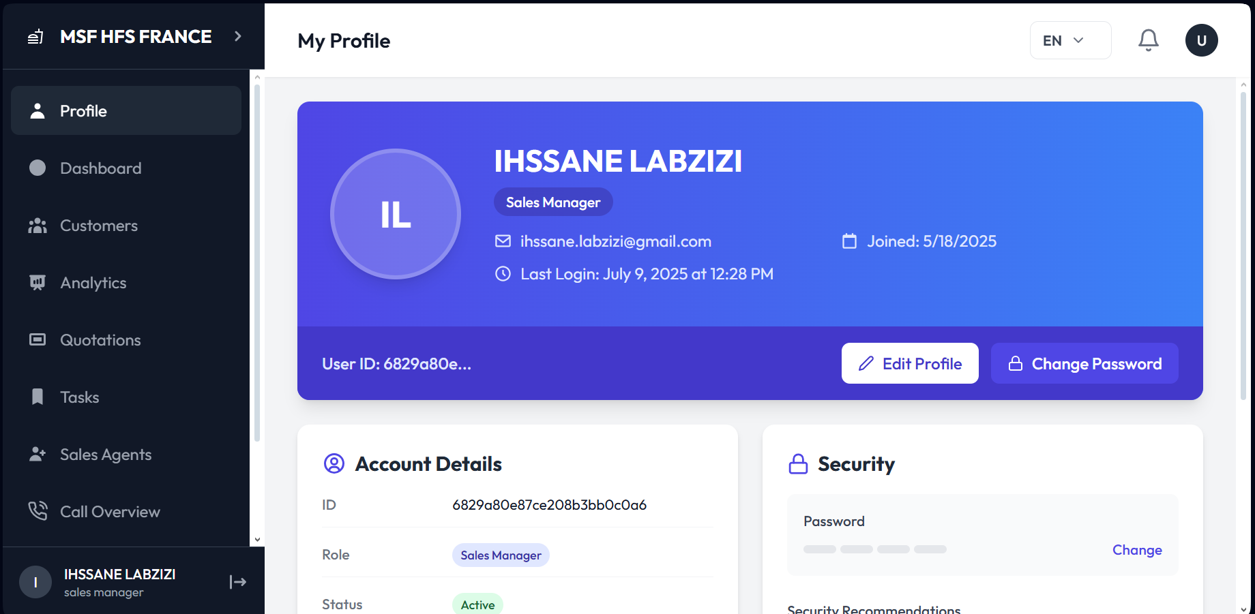

Fig 5. An overview of your profile

## View Profile:

You will see the following details on the **account details** section of your **profile** as shown in Fig 5 and 6**:**

* Name
* Role
* Email
* Phone Number
* Joining date
* Last login
* User ID
* Status

This information helps you verify and manage your account details

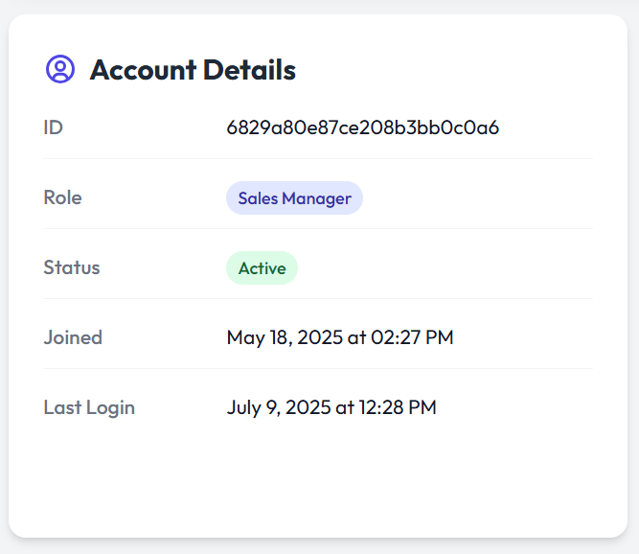

Fig 6. Sales Manager account details on the profile

## Edit Profile:

You can also update your profile details by clicking on the **edit profile** button as shown in Fig 7.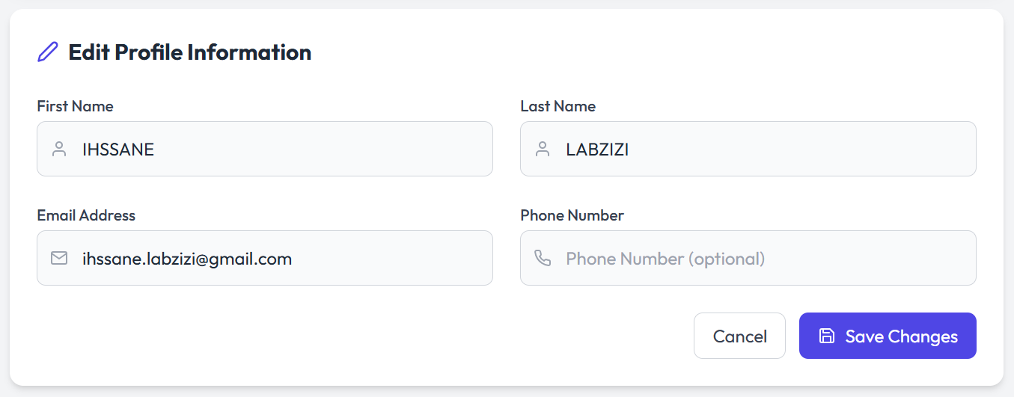

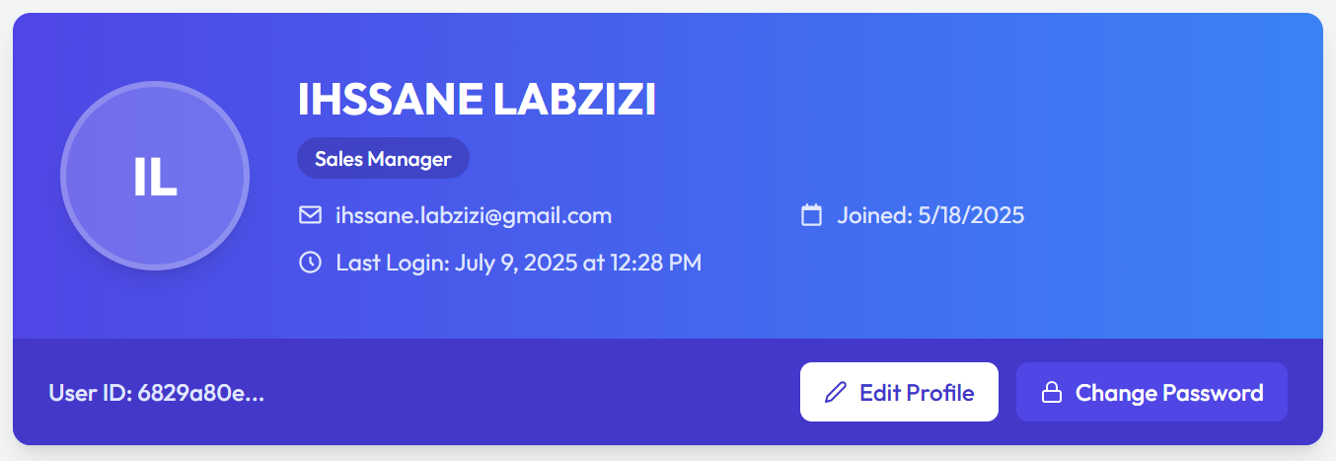

Fig 7. Editing the profile of a sales manager

You can edit the following things on your profile:

* Name
* Phone number
* Email

## Changing Your Password:

To change your password you click on the **change password** button on your profile as shown in Fig 5 and follow the following steps:

* Enter current password
* Enter and confirm new password
* Click the **update password** button
* You can also click cancel if you do not want to change the password

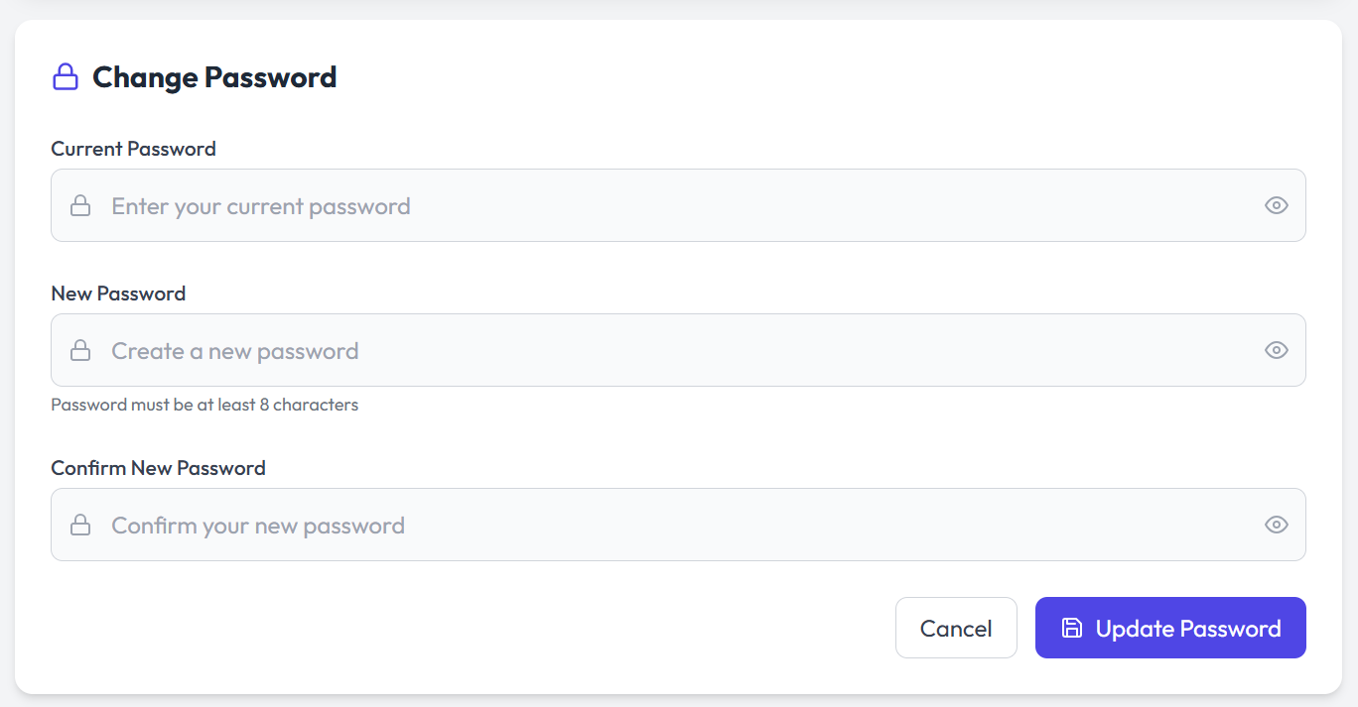

Fig 8. Changing password on sales manager profile

As you scroll to the bottom of the profile page you see a **logout** button on the bottom right. You can log out by clicking that.

# Access and manage your customers:

You can shift to the customers page by clicking on the **customers** button on the left panel on the screen. Once you switch the screen you land on the **customers** screen as shown in Fig 9. Here you can view some basic analytics as well as the details of the customers. Some basic analytics that can be viewed are:

* Total customers
* Active customers
* Inactive customers
* Unassigned
* Added (in the past 30 days)

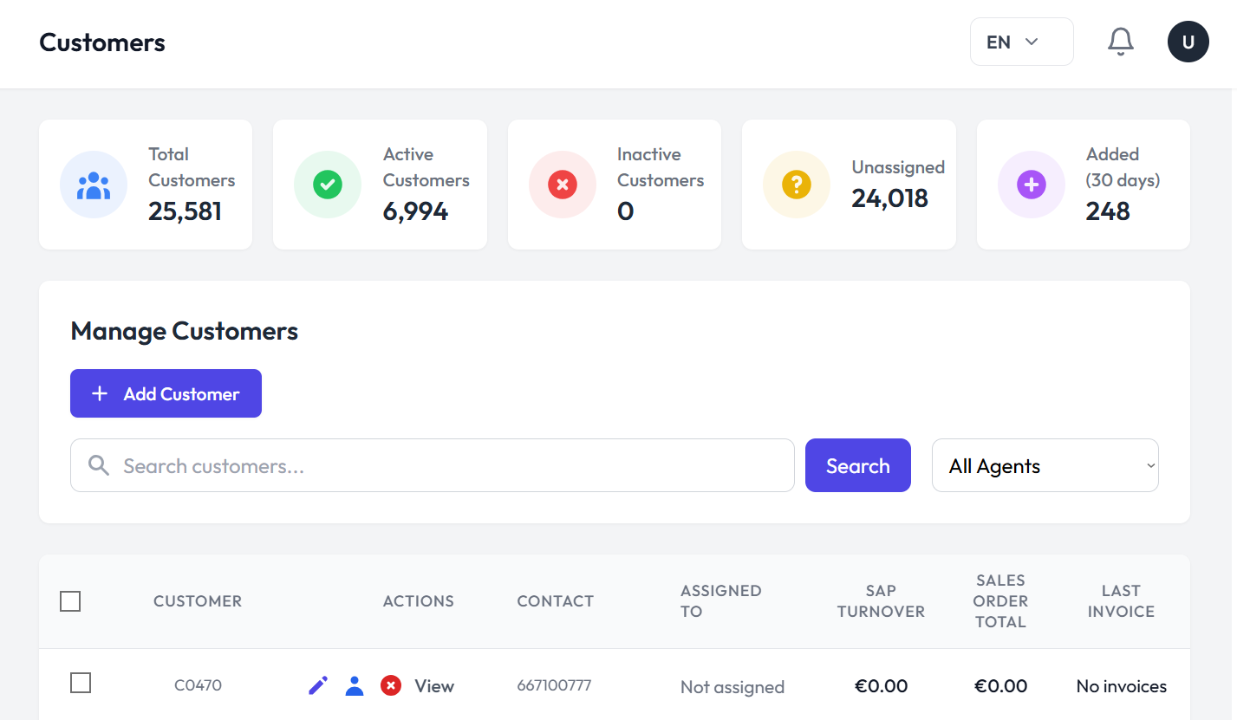

Fig 9. Customer dashboard

## Add a New Customer:

You can add a new customer to your dashboard by clicking on the **add customer** button on the customer management dashboard as shown in Fig 9. To add a new customer:

* Click the add customer button
* Fill out the basic information form shown in Fig 10

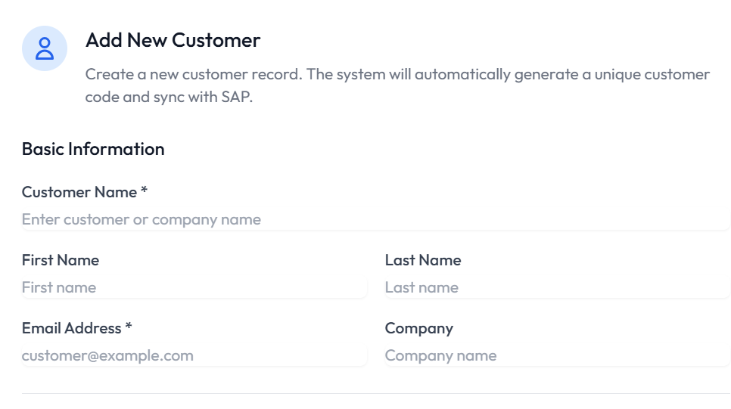

Fig 10. Basic information form on add new customer page

* Fill out the contact information form shown in Fig 11.

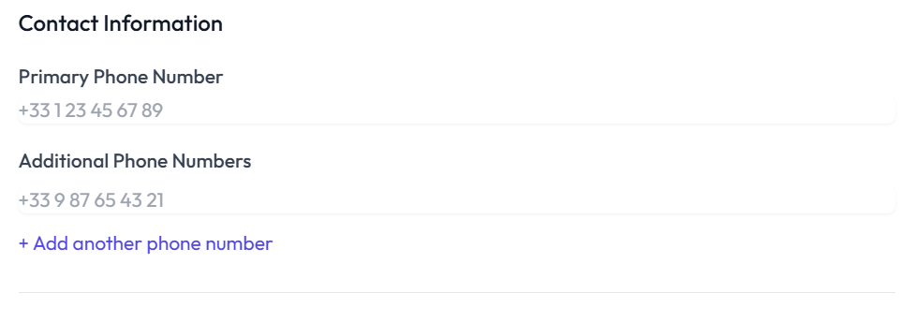

Fig 11. Contact information form on add new customer page

* Mark the status and assign sales agent as shown in Fig 12
* Add additional notes if you want to
* Click **create customer** button as shown in Fig 12

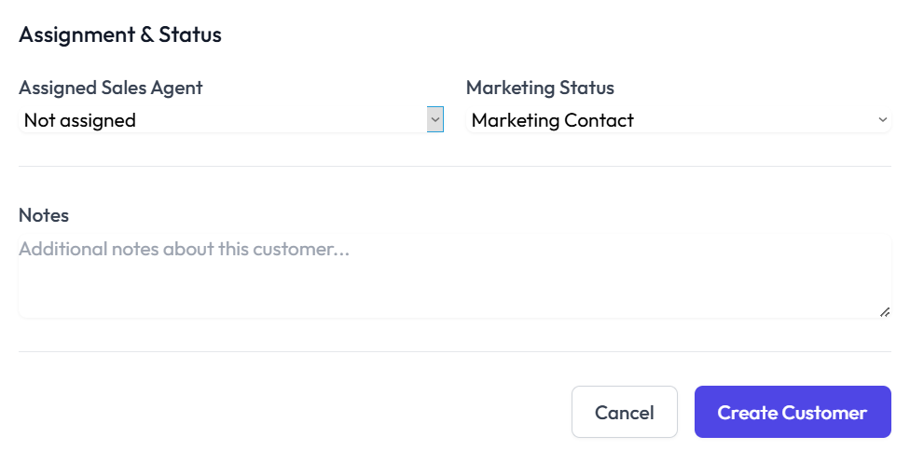  
   
Fig 12. Assignment and Statues, Notes and Create Customer button on the create new customer page

## Search a Customer:

You can search for a customer by writing their name in the search box at the top of the customers screen and pressing the **search** button as shown in Fig .9

## Viewing Customer Details:

You can view the customer screen as shown in Fig 9. You can view the following details:

* Customer/Company name
* Actions
* Contact
* Assigned to
* SAP turnover
* Sales order total
* Last invoice
* Invoices
* Orders
* Quotations
* Abandoned carts
* Status

## Managing Customer Information:

You can manage customer information by going over to the **actions** column on the customer dashboard and clicking on the **edit** button as shown in Fig 9. You can edit the following details:

* Customer name
* Customer code
* Email address
* Phone Number

Click on the **Update Customer** button to update the information and **cancel** button to cancel the changes. You can see in Fig 13 the detailed form of customer update.

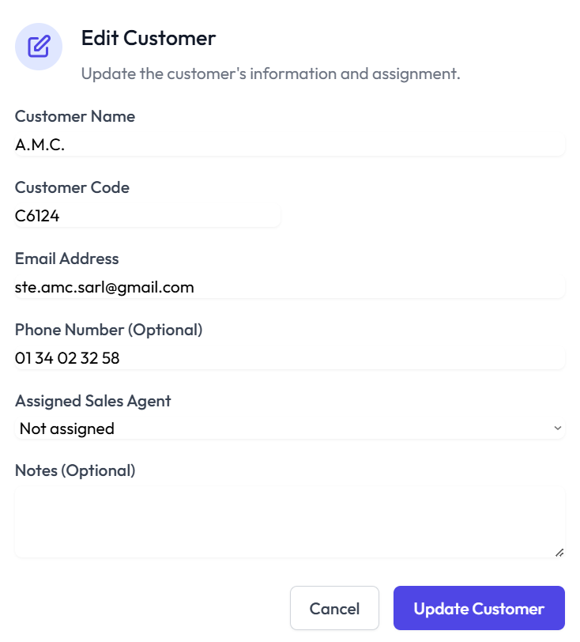

Fig 13. Edit customer form

## View Customer Journey:

You can view customer journeys by clicking on the **view** button on the actions column on the customer dashboard as shown in Fig 9. You can view a detailed report of each customer by clicking on their view button as shown in Fig 14 and Fig 15.

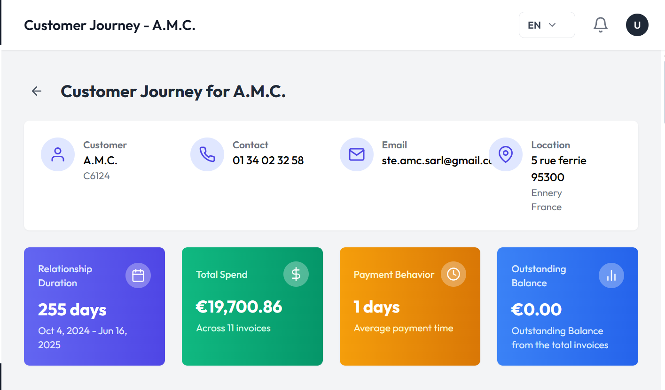

Fig 14. Customer Journey Dashboard

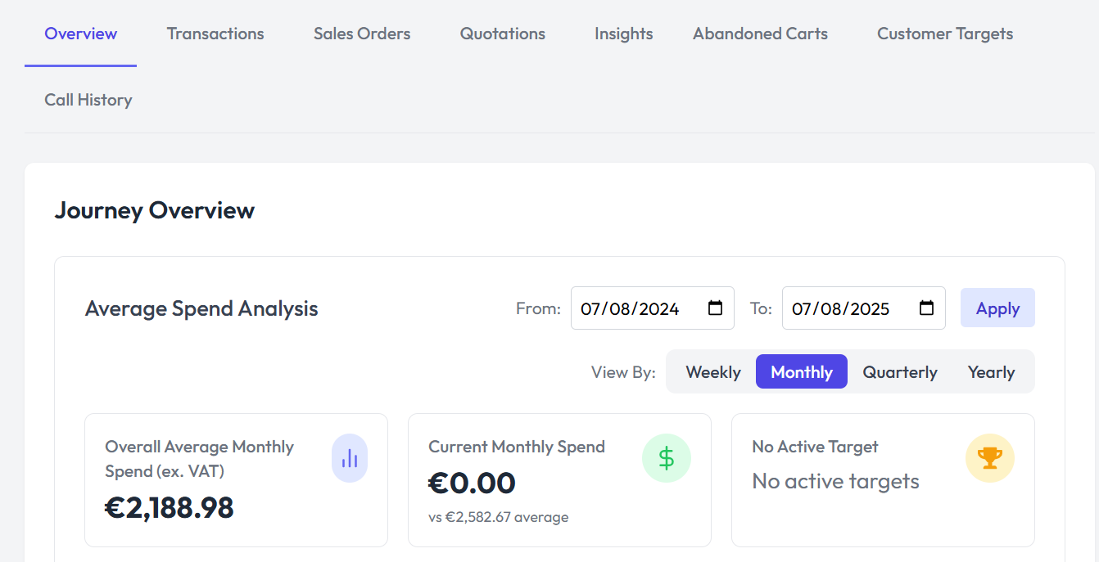

Fig 15. Customer Journey Dashboard

# View Team Analytics and Performance:

You can view your team analytics overview on the team analytics screen. Here you can view:

* Team members
* Team target amount
* Team achievement
* Completed targets
* Top performers of your team
* Recent activity

For reference see Fig 16.

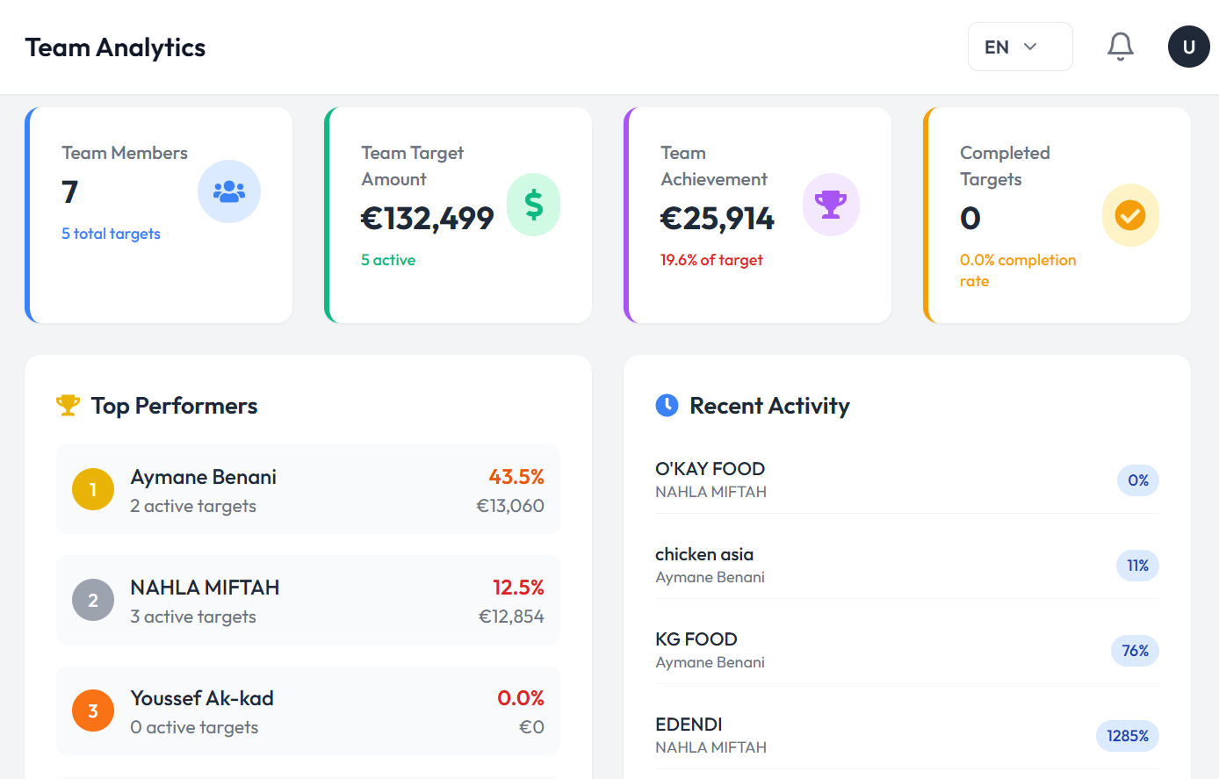

Fig 16. Overview of team performance

By clicking on the **Agents** button on the top right of the team analytics you can see all your agents their target amount, their target achieved and the progress they have made so far. For reference Fig 17.

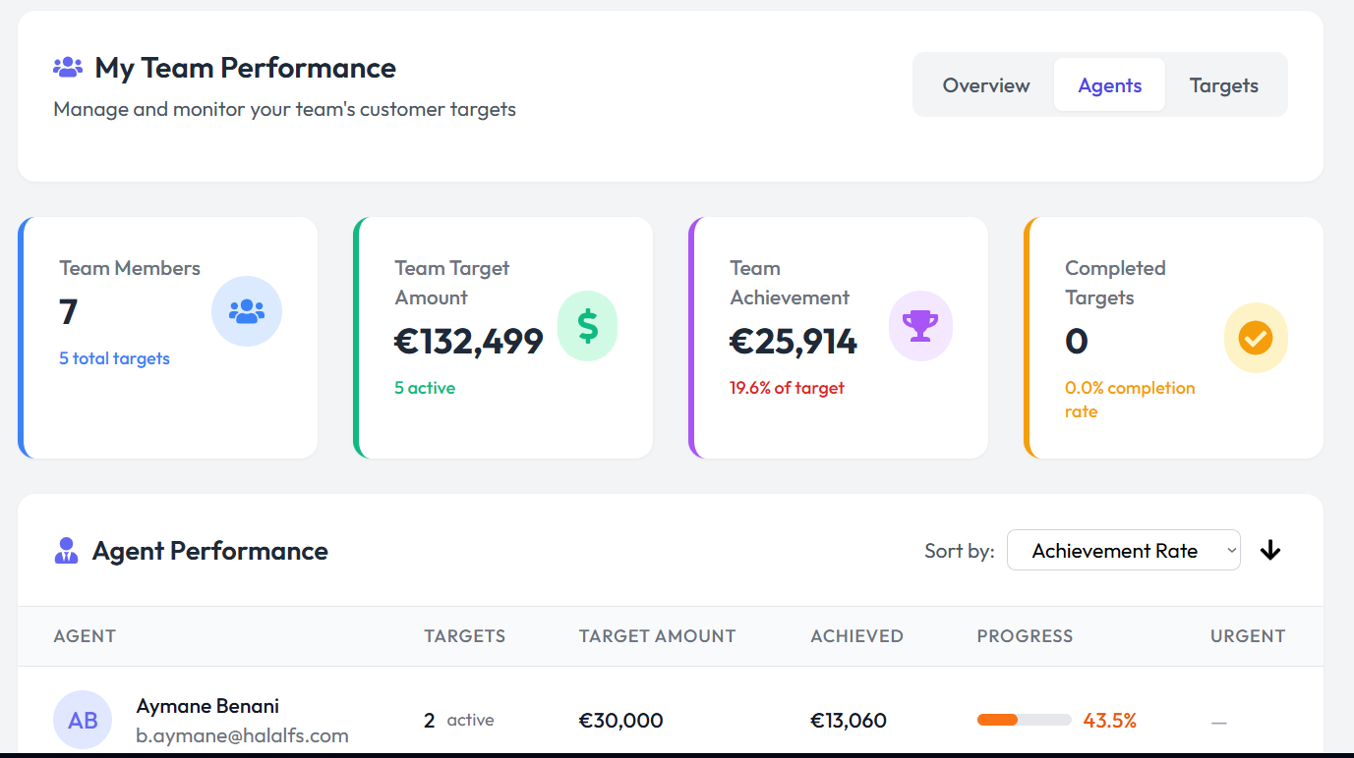

Fig 17. Agents overview and their progress

By clicking on the targets button you can then view the active team targets as seen in Fig 18.

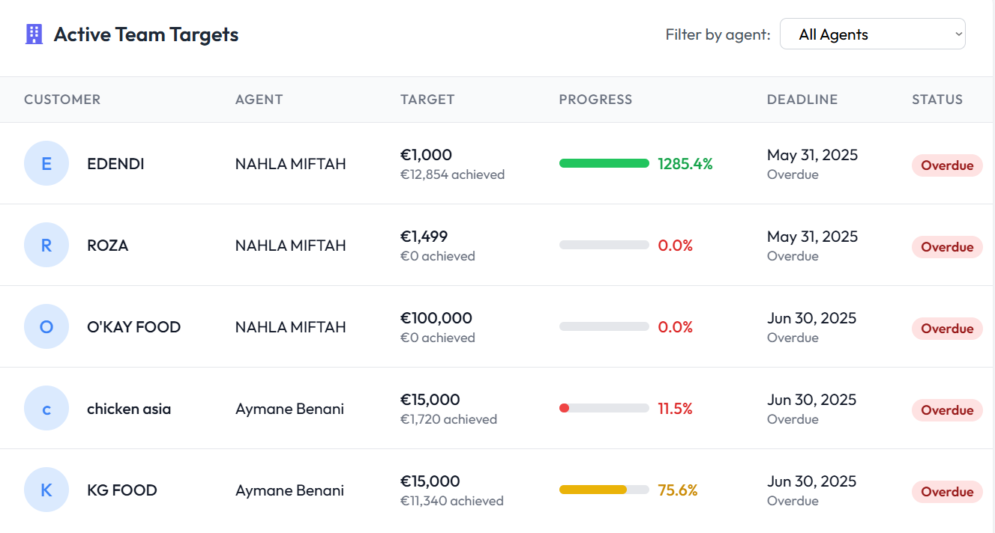

Fig 18. Active team targets, their deadlines and status

# Viewing and Managing Quotations:

By going to the quotations tab you can view and manage the quotations that are sent to the customers by the sales agents by using some actions. The actions that can be used are:

* View
* Edit
* Duplicate
* Print
* Send email
* Generate payment link
* Delete

You can see all these actions in Fig 19.

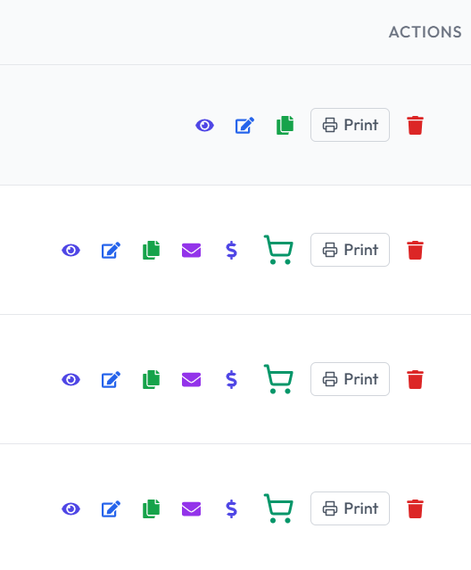

Fig 19. Actions that can be performed for quotations

Moreover you can also have an overview where you can see:

* Total quotations
* Total value
* Pending approvals
* Conversion rates

This can also be seen in Fig 20.

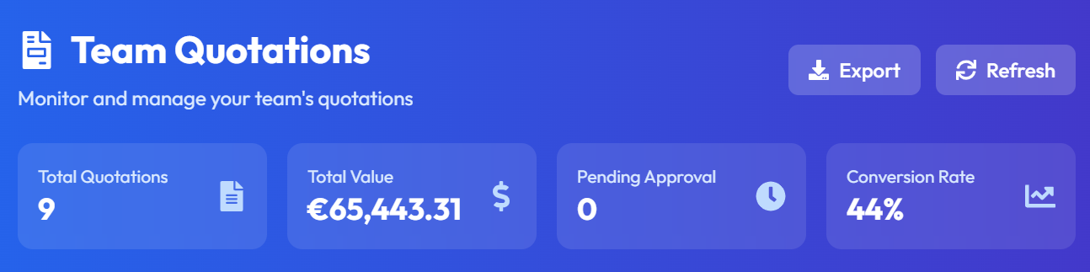

Fig 20. Overview of the quotations

You can also view if a quotation is rejected or approved by looking at the status column of the quotations dashboard.

# Create and Manage Tasks:

The tasks section helps you stay organized and focused on the daily sales activities. It allows you to create, track, and manage tasks. You can view the Pending, Awaiting approval and completed tasks here.

## 

Fig 21. Task Board

## Creating a New Task:

You can create a new task by clicking on the **new task** button on the Tasks screen as shown in Fig 21. Fill out the information in the form as shown in Fig 22. The information to be filled is:

* Title
* Description
* Assign to
* Priority
* Type
* Due Date

Click on the **create task** button to create a new task and **cancel** button to exit the screen as shown in Fig 22.

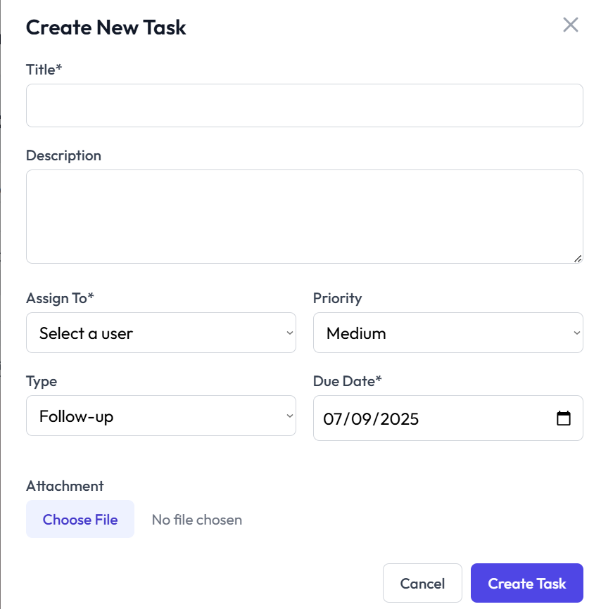

Fig 22. Create new task form

## Create New Lead:

You can also create a new lead by clicking on the **new lead** button on the task screen as shown in Fig 21. Fill out the information in the form, as shown in Fig 23 , such as:

* Full name
* Email
* Phone number
* Company
* Status
* Tags
* Notes

Click on the create lead button to create a new lead or cancel button to exit the form.

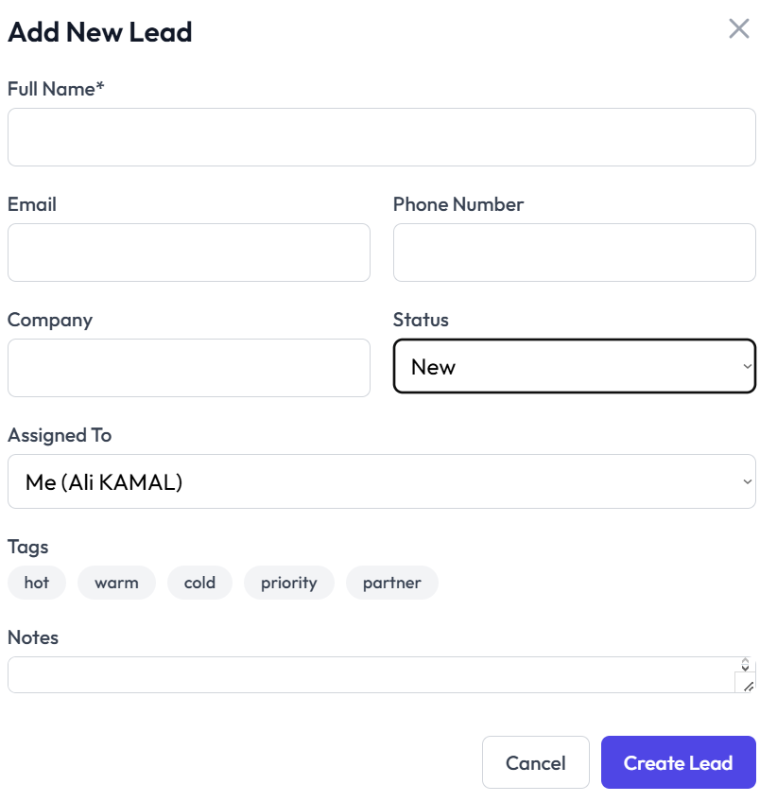

Fig 23. Add new lead form

# Sales Agents:

Here you can view all the sales agents that are a part of your team. You can also search sales agents.

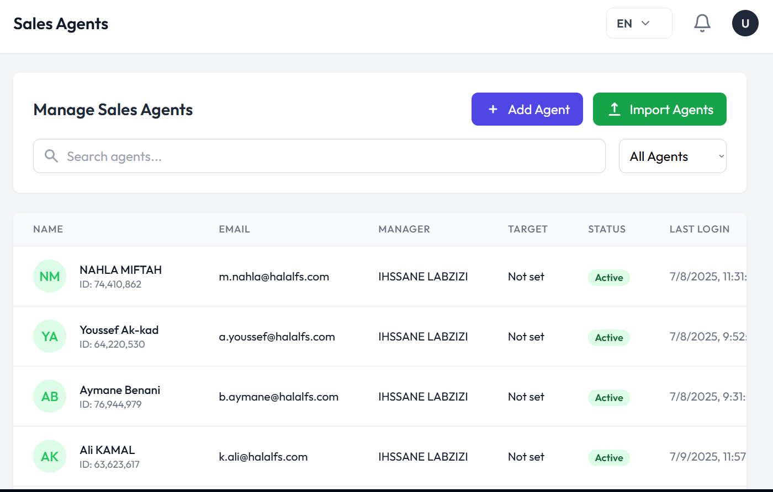

Fig 24. Sales agent overview

## Adding a New Agent:

You can add a new agent to your team by clicking on the **add agent** button as shown in Fig 24.

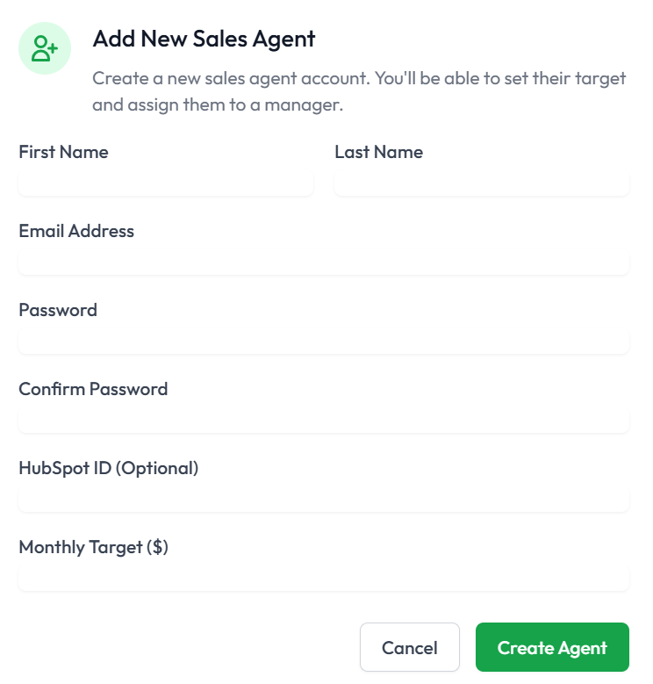

Fig 25. Form to add new sales agent

Then fill out the basic information in the form shown in Fig 25 and press the **create agent**  button.

## Import Sales Agent:

You can also add multiple new sales agents by importing an excel file as shown in Fig 26.

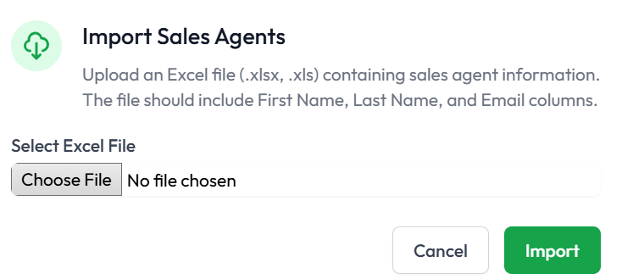

Fig 26. Importing multiple sales agents using excel files

Press the **import**  button and multiple sales agents will be created.

## Actions:

You can perform multiple actions on each sales agent in your team. Some actions include:

* Editing sales agent profile
* View sales agent profile where you can reset profile, view an overview, targets, customers and other details of each sales agent
* Reset password
* Deactivate profile

# Call Analytics and Overview:

You can view the call analytics and overview by moving to the call overview tab. Here you can see multiple things that can be viewed in Fig 27.

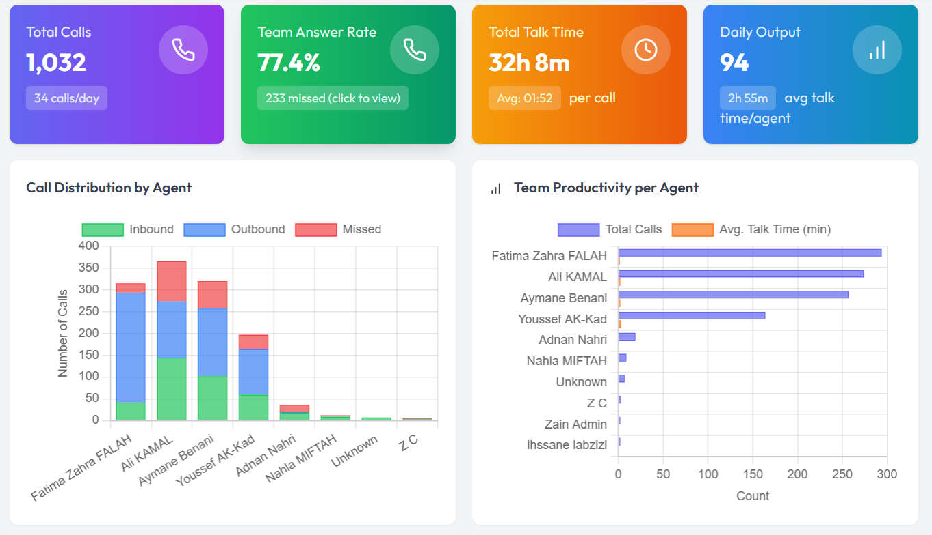

Fig 27. Call analytics of the team overall

You can also view individual **agent performance** where you can see a detailed overview and call analysis of each agent individually. By clicking on the **view details** button in the action column of a specific agent you can see the following statistics of that agent:

* Call summary
* Daily breakdown
* Hourly output
* Call log

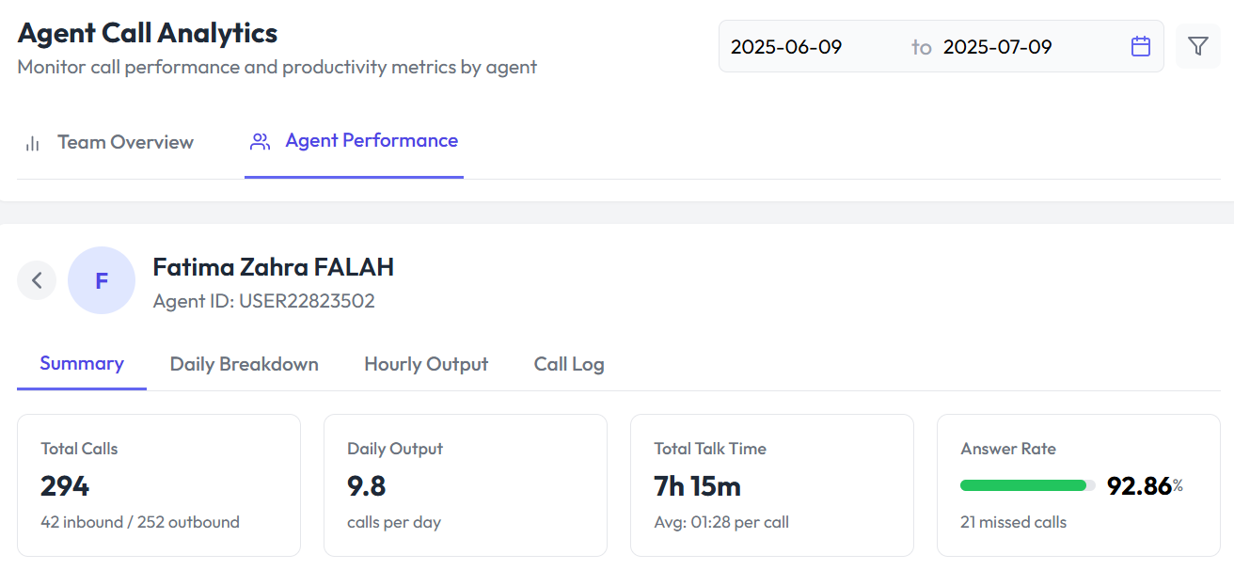

Fig 28. Call analytics of an agent individually

# Customer Targets:

You can manage and view customer targets such as:

* Total targets
* Total targets achieved
* Total achieved
* Targets closing soon

You can also add a new target by clicking on **add new target** and assign it to an agent.

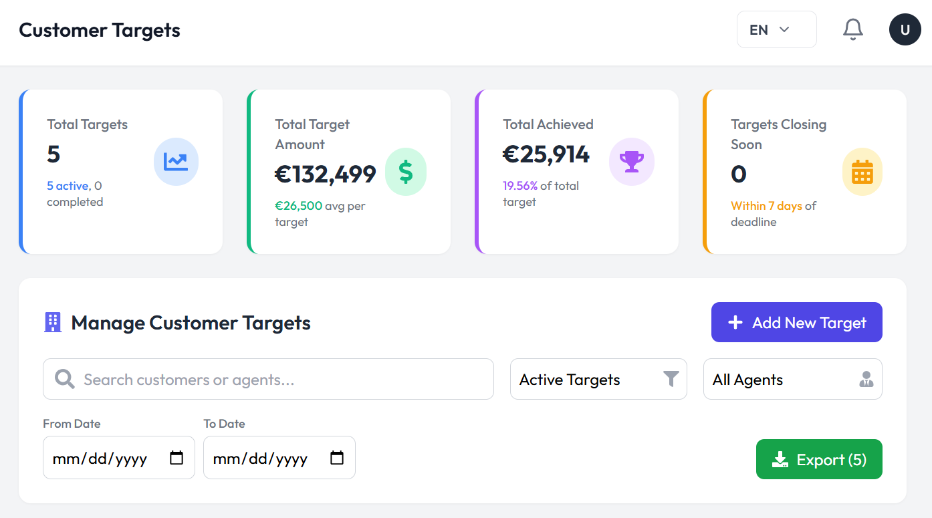

Fig 29. Customer target dashboard

You can also view the status of the target (active/in-active). You can also edit the targets by going over to the actions column and clicking the **edit** button

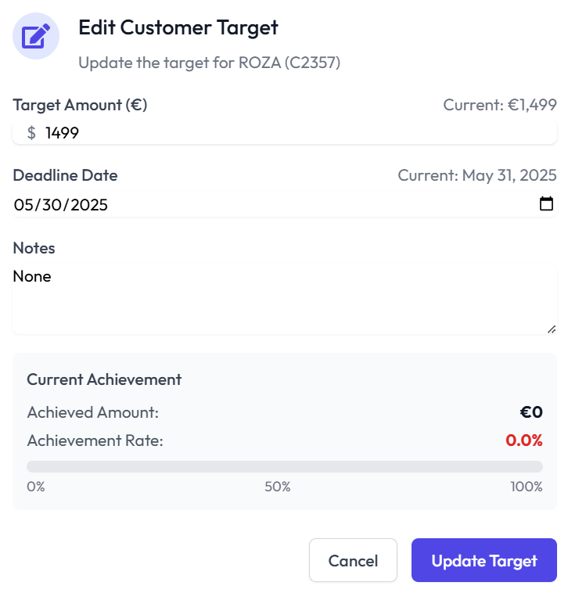

Fig 30. Edit and update customer targets

# Abandoned Carts View:

Abandoned carts can be viewed by going to the abandoned cart analysis tab where you can see an overview of the abandoned carts such as:

* Abandoned carts
* Potential lost revenue
* Recovery opportunities
* Conversion rate

You can see the overview in Fig 31.

# 

Fig 31. Overview of abandoned carts

You can view the top products that have been abandoned in the top abandoned products list as shown in Fig 32.

# 

# 

Fig 32. Top abandoned products view